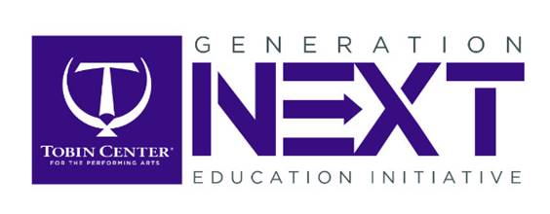

**The Tobin Center is proud to present**

**our Gala Benefit Concert**

**in support of Generation NEXT:**

***Straight Up PAULA!***

**and YOU are invited to be our Charlie Seat guest!**

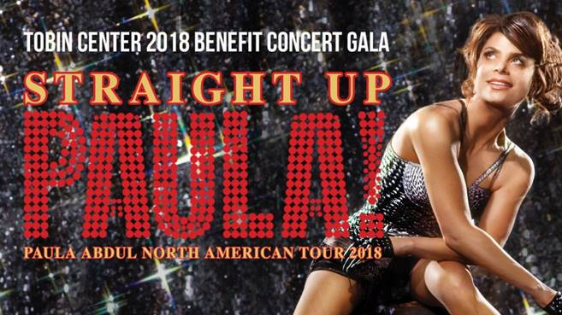

**Students are who this benefit concert is for!  
Please, come and celebrate with us on**

**December 5th, 8:00 pm.**

**cid:image005.png@01D4880A.47C1CA00**

**To make your reservation:**

* + **Fill out the form below**
  + **Copy and paste into an email to:**
    - **Dr. Kimberly Stephenson (**[**kimberly@tobincenter.org**](mailto:kimberly@tobincenter.org) **)**
  + **Your tickets will be waiting for you in Will Call.**
    - **Please bring your photo ID (or have your parent bring theirs.)**
  + **Deadline for Charlie Seats tickets: *noon on Monday, 3 December*.**

**Charlie Seats Tickets**

***Straight Up PAULA!***

Student name:

Parent name:

Email address:

School name:

Phone number:

Address:

Two Tickets

Please email to: [kimberly@tobincenter.org](mailto:kimberly@tobincenter.org)

*Deadline for tickets: noon on Monday, 3 December.*

**We hope to see you there!**

**See the fun to come…**

<https://vimeo.com/291793473>



<https://www.tobincenter.org/box-office/2018-12/paula-abdul>